Dynamics of Greater Sage-grouse (Centrocercus urophasianus) Populations
in Response to Transmission Lines in Central Nevada

Progress Report: Year 8
December 2010

Erik Blomberg, Dan Nonne, James Sedinger
Department of Natural Resources and Environmental Sciences
University of Nevada – Reno
1000 Valley Road
Reno, NV 89512
Abstract:
To characterize demographic processes in Greater Sage-grouse (Centrocercus urophasianus), we monitored 13 lek sites in a ~6500 km² area in Eureka County, Nevada. The long-term goal of this ten-year study is to assess the impact of NV Energy’s Falcon-Gondor transmission line on sage grouse demography and population dynamics. We used mark-recapture, lek observations, nest & brood monitoring, vegetation sampling, and radio telemetry to estimate key demographic parameters. A total of 1165 unique individual sage grouse have been banded during the first eight years of the study. From 2003-2007, counts of common nravens along the transmission line corridor and raven-associated disturbances at leks increased dramatically, however, in 2008 raven counts declined to levels observed immediately following line construction, and increased but remained low in 2009 and 2010. A Program MARK known fate analysis showed that population, month, season of capture, and breeding success influenced female survival. Monthly survival was lowest during the months of September (0.92 ± 0.02 SE) and April (0.91 ± 0.02 SE). Survival was higher for birds associated with the Roberts Creek Mt. population than for the Cortez population, and hens that successfully fledged broods were predicted to experience lower survival than hens that did not. Females that were captured during the spring breeding season had higher annual survival than those captured during the fall trap (.591 ± .025 SE and .541 ± .041 SE). We conducted additional known-fate analyses to evaluate temporal, spatial and habitat impacts on fall survival. We found substantial temporal and spatial variation in fall survival both within and among years that was best characterized by trends in weekly survival. These results showed that survival tended to increase, decrease, or remain stable within populations and years, irrespective of conditions in the adjacent population or during previous years. Additionally, we evaluated data from a subset of females that were followed more closely on the ground. Habitat conditions at female locations that most influenced survival, as well as temporal patterns in predator communities responsible for female mortality, suggest that top-down forces may regulate survival of females during the fall. Nests were monitored to estimate success, with nest site vegetation characteristics measured after hatch and evaluated as covariates in a nest success analysis in Program MARK. Model results showed a population-level effect on nest success; hens from the Roberts Creek Mt. population had higher nest success than hens from the Cortez population (0.214 ± 0.045 SE and 0.178 ± 0.032 SE, respectively). Additionally, we found interactive effects between wildfire impacts and road density, such that nest success was lowest in areas impacted by roads, and highest in non-burned roadless areas. We used Pradel models in Program MARK to directly estimate population growth, λ, as well as survival and seniority from male capture/recapture/resight data. This allowed us to directly compare estimated λ to observed lek trends as a means of evaluating the efficacy of lek counts. Male survival varied by year, and ranged from a low of 0.568 (± 0.06 SE) in 2006 to a high of 0.801 (± 0.06 SE) in 2004. In general, annual lek count trends did not agree with Pradel λ, however long-term trends were more consistent. A robust-design analysis of our male capture-recapture data has shown that variation in breeding propensity may be largely responsible for annual variation in lek counts. Overall our results continue to support demographic differences between the Roberts Creek and Cortez populations, and suggest that sage grouse in the Cortez Range are at higher risk. Variation in habitat conditions, driven at least in part by wildfire, partially explain this variation for male survival and nest success, whereas variation in predator communities and costs associated with reproduction may limit female survival.

Introduction:
Range-wide sage-grouse populations have declined since the mid 1960s, with some states showing stabilizing trends in the past two decades (Connelly et al. 2004). Sage-grouse are an obligate of sagebrush, with both adults and young using this vegetation for food and shelter throughout the year and subsisting solely on it during the winter months (Beck 1977, Dalke et al. 1963, Wallestad et al. 1975). Human disruption of the sagebrush biome has contributed to the loss of approximately 530,000 square kilometers of sagebrush steppe habitat (Crawford et al. 2004, Connelly et al. 2004, Dalke et al. 1963). Given the amount of sagebrush steppe lost and sage grouse dependency on sagebrush, it is believed that the loss and degradation of habitat is an important cause of population decline (Connelly et al. 2000).
Elevated structures, such as utility lines can supply perches for avian predators that are higher than those supplied by local vegetation and topography (Ellis 1984, Braun 1998). There has been only one post-hoc study of the impact of utility lines on sage grouse (Hall and Haney 1997). Though Hall and Haney (1997) showed generally lower lek attendance at leks closer to utility lines, they were unable to account for confounding factors that may have influenced both utility line placement and sage-grouse populations. It is hypothesized that avian predators of sage grouse adults (raptors) and nests (corvids) may use utility poles and towers to increase their hunting efficiency, which could lead to decreased adult survival and/or nest success, thus triggering population declines in nearby leks (Hall and Haney 1997, Alstatt 1995). Alternatively, the perceived threat of predation associated with utility lines may also cause sage-grouse to avoid utility lines, effectively causing sage-grouse to abandon those leks, nest sites, and brood rearing areas near utility lines (Hall and Haney 1997, Braun 1998).
There has been some recent indirect evidence in support of the avoidance hypothesis, in that lek locations have been found to have the least long range visibility in combination with the greatest short range visibility that the local topography will allow (Aspbury et al. 2004). In short, male sage-grouse may be choosing lek locations that maximize their visibility to female grouse near a lek, while at the same time reducing the long range visibility of the lek to predators (Aspbury et al. 2004).
In fall 2003 Sierra Pacific Power Company (now NV Energy) began construction of a 345 kilovolt transmission line between Falcon and Gondor, Nevada (FG line). Construction of the FG line was completed in the spring of 2004 and the line was energized in May of that year. The FG line is approximately 290 km long and has 735 towers that vary in height from 23 to 40 m, depending on the topography. The path of the FG line places it in the middle Eureka County’s prime sage grouse habitat (M. Podborny, NDOW, personal communication).
Objectives:
The goal of this study is to assess impacts of the FG line on the dynamics of the population of greater sage-grouse in the region. The basic study design calls for estimation of key demographic parameters as a function of distance from the line. Under the hypothesis that the line negatively affects local sage-grouse, we expect that demographic responses to the line will be greatest for leks and/or individuals nearest the line. Distance from the line will be directly incorporated into models of demographic parameters to assess this hypothesis. For parameters for which we hypothesize a time delayed response (e.g., adult survival following an increase in raptors) the appropriate analysis includes a time by distance interaction. Thus, though it may not be immediate, we expect (under the hypothesis of an impact of the line) a greater decline in adult survival for leks near the line than for leks distant from the line.
To this end, several leks at varying distances from the FG line were chosen to be monitored for ten years. At each of these leks a regime of capture-mark-recapture and observations throughout the strutting season was initiated. We also radio tag a sample of hens captured each year and follow these hens throughout the strutting, nesting, and brood-rearing seasons. From 2005-2008, we have used a combination of Passive Integrated Transponder (PIT) tags and patagial tags to permanently mark sage grouse chicks. Also in 2005, we began what has become an annual fall trap with Nevada Department of Wildlife (NDOW) to increase the number of radio-tagged individuals in the population, hunter band returns and the number of radio tagged young. These methods will allow us to assess dynamics of demographic parameters (male lek attendance over time, movement between leks, adult survival rates, nest success, brood survival, recruitment, and population size) in relation to distance from the FG line.
Study Area:
The study site is located in central Nevada within Eureka County (Fig. 1). It is bounded by the Cortez and Simpson Park Mountains to the west and the Diamond and Sulphur Spring Mountains to the East. This area includes Denay, Pine, Kobeh, Diamond, Horse Creek, Grass, and Garden valleys. The study area encompasses approximately 6500 km² of sagebrush steppe and pinyon-juniper mountain ranges with many ephemeral streams. Sage grouse utilize two main sagebrush communities in the study area. At low elevations (< ~7000 ft), a Wyoming big sage (A. tridentata wyomingensis) community is dominant, with pockets of black sage (A. nova) and basin big sage (A. tridentata tridentata), as well as rubber rabbitbrush (Chrysothamnus nauseosus), greasewood (Sarcobatus vermiculatus), and some scattered Utah juniper (Juniperus osteosperma). At higher elevations (> ~7000 ft), a mixed mountain big sage (A. tridentata vaseyana)/low sage (Artemisia arbuscula) community is most prevalent, with some intermixed common snowberry (Symphoricarpos albus), western serviceberry (Amelanchier alnifolia), and bitterbrush (Purshia tridentata). Large expanses of singleleaf pinyon (Pinus monophylla)/Utah Juniper forest are also common in the study area, and in many cases are found mid-elevation between the two sagebrush communities. Common annual and perennial forbs include phlox (Phlox spp.), cateyes (Cryptantha spp.), tansy mustard (Descurainia pinnata), bur buttercup (Ceratocephala testiculata), woolystar (Eriastrum spp.), lupine (Lupinus spp.), desert parsley (Lomatium spp.), and desert buckwheat (Eriogonum spp.). Grasses consist of blue grass (Poa spp.), cheatgrass (Bromus tectorum), crested wheat (Agropyron cristatum), indian rice grass (Achnatherum hymenoides), and squirrel tail (Elymus elymoides).
The study area includes 120 km of the FG line and focuses on thirteen active leks at various distances from the FG line (Fig. 1). Five of these leks have been monitored by NDOW and the Bureau of Land Management (BLM) for the past thirty years. These long term data show male lek attendance at these leks has been declining since the early ‘70s with some signs of stabilization in the late ‘90s (Fig. 2).
Methods:
Mark Recapture: The predominant trapping method used to capture adult sage grouse was night spotlighting (Giesen et al. 1982). We used a high candlepower spotlight to disorient birds while a dip net was placed over them, with white noise generated throughout to mask researcher movement. Binoculars and eyeshine were used to increase the distance at which birds are detected (Wakkinen et al. 1992). To supply power for the spotlight and white noise we used either an ATV or a portable generator strapped to a backpack frame. Small diameter mesh (Giesen et al. 1982) or rubber netting was used to decrease damage to plumage. Although other methods were tried such as ground mounted rocket nets (Giesen et al. 1982) and walk-in traps (Schroeder et al. 1991), we were unsuccessful with these methods.
During the breeding season, we captured individuals on each study lek and the surrounding area approximately once a week. During the late summer/early fall trap, known brood rearing areas and ridges were scouted one week before the trap, and then intensively trapped for three nights during the new moon in August or September. Upon capture, birds were aged, sexed, weighed, and a series of morphological measurements were taken (length of 1st primary, 5th primary, wing chord, tarsus, foot, and number of tail feathers). Each bird was banded with a National Band and Tag metal band, size 16 for males and 14 for females (Walsh 2002), and all adults and those young that were large enough were banded with a colored plastic band engraved with three character alpha-numeric code for re-sighting during lek observations. All hens captured during the lekking season and a subset of hens captured during the fall trap were fitted with a radio necklace. A subset of males were radio tagged in both the spring and fall. We used radios from Advanced Telemetry Systems, model number A4060. Each radio weighed approximately 22 g, had a battery life of 383-766 days, and a range of 1-5 miles depending on terrain.
Lek Observations: We monitored ten viable leks in 2003, eleven leks in 2004 & 2005 twelve leks in 2006 & 2007, and 13 leks in 2008-2010, within 20 km of the transmission line. Six leks were within 5 km of the FG line, while seven leks were greater than 5 km away. Leks were selected by evaluating previously collected data from the BLM and the NDOW. Precise locations of monitored study leks are shown in Figure 1.
Each study lek was observed approximately once a week throughout the breeding season, March through May. Observers arrived on the leks 1/2 hour before first light, and remained until strutting activity ceased or the birds disbursed (Walsh 2002). During these periods, researchers monitored leks from mobile blinds with high-powered (15x60) spotting scopes and binoculars. We occasionally included a mobile observation tower to facilitate band reading where terrain permitted and vegetation characteristics required it. We counted the number of males and females, marked and unmarked, on leks every 30 minutes during each observation period. We also recorded individual band codes (resights) and behavioral interactions with potential predators. For lek disturbances, bird behavior, time, number of birds affected, and type of predator/disturbance were recorded.
Radio Telemetry: During the nesting season (late March to mid June) each hen was located at least once weekly either visually or by triangulation. Once a radio-collared hen initiated a nest she was monitored twice weekly from a distance until the nest hatched or failed. After hatch, hens were flushed and chicks counted once a week until fledging, approximately 45 days post hatch (Schroeder 1997). Once a brood fledged, hens were located approximately once a week using triangulation. Following nest failure hens were returned to the breeding season regime above. If a nest failed after strutting ceased the hen was located approximately once a week using triangulation. After all radio-collared hens had fledged their young or failed, they were monitored approximately once a month using fixed-wing aircraft until the next breeding season. From August – October in 2008, 2009, and 2010, we initiated a more intensive monitoring program in response to increased fall mortality observed in previous years. This was done in part to detect possible mortality associated with West Nile Virus, as well as to monitor habitat use during the fall period. All radioed birds were monitored 4-7 days/week for survival, and a subset of radioed hens were flushed 1x / week. Shrub and understory vegetation were sampled within 10m of each location using methods similar to those described below for nest vegetation monitoring. When a mortality signal was detected, the collar was recovered as rapidly as possible, the mortality site was assessed and cause of death determined.
Nest Monitoring & Vegetation: Upon locating a nesting hen, a visual check point at least twenty meters away was marked with a cairn of rocks or local debris and a GPS point recorded. If environmental conditions were favorable – no storm on the horizon and no predators seen nearby – the hen was approached and flushed from the nest. Size of clutch was recorded, eggs were floated to determine stage of incubation, and each egg’s length & width was measured. Age of each nest was estimated using egg float data, assuming incubation began with laying of the last egg and one egg was laid every 1.3 days (average laying time per egg [Dalke et al. 1963]). Within 24 hours the nest was checked again from a distance to confirm the hen’s return. Once the hen’s return was confirmed, nest monitoring followed the twice weekly regime until hatch or failure. A nest was determined successful/hatched if the hen was located nearby with chicks or if at least one egg was present with crown removed and/or the shell membrane was present and detached.
Vegetation was measured around each nest site within 3 days of hatch, or on the predicted hatch date for failed nests. We placed two perpendicular 10 m transects centered at the nest and recorded the percent shrub cover for each meter along the transect (Gregg 1994). In addition, five 20 X 50 cm Daubenmire plots were placed along each transect, where percent cover of grass and forbs was estimated and all plants were measured and identified to species. The same data collected for the Daubenmire plots were also collected for the m² area around the nest bowl (Sveum 1998). These same vegetation measurements are also made at 24 control points, randomly placed throughout the study area each year.
Brood Trapping, Monitoring, & Vegetation: Within three days of hatch broods were trapped and processed (Gregg 2001). Like Gregg (2001) we found hens to still be brooding their young during the hours before dawn within 2 to 3 days after hatch. Hens were flushed and the young were gathered up by hand and placed in a cloth sack, which was then placed inside a researcher’s jacket to maintain chick body temperature. Processing involved weighing the individual chicks, measuring their tarsus, foot, and length of bill to back of the head, as well as uniquely marking each individual (Carver et al. 1999, Becker et al. 1997). In 2005 and 2006 we used passive integrated transponder (PIT) tags. In 2007 we included to patagial wing tags (#1 fish fingerling tags), and double marked all chicks with one PIT and one wing tag. In 2008 we completely shifted to using only patagial wing tags in both wings, and continued this practice through 2010. After processing, chicks were placed in another cloth sack which was also placed inside a researcher’s jacket and checked periodically to determine condition. Once processing was completed, the entire brood was released together and researchers moved away from the brood in the direction opposite where the hen was last heard or seen. Throughout processing the brood the hen’s position was periodically determined via radio or visual check, and we remained in the area long enough to confirm reassociation of the hen and chicks.
After capture, broods were checked once a week, hens were flushed and chicks counted to determine fledging and survival rates. In 2008, we modified brood check procedures to increase the precision of our brood count estimates. From initial capture to ~ 30 days of age, each brood was flushed weekly during the early morning while the chicks were still congregated near the hen. Following 30 days, chicks were counted while roosting at night using a spotlight and binoculars/spotting scope. We continued to collect a daytime location once a week for vegetation monitoring, however lower importance was placed on obtaining a mid-day flush count. Each daytime location was recorded using a GPS and we returned in 3-6 days to measure vegetation. Vegetation measurements were the same as those for 10 m nest transects. In addition to the vegetation measurements, we placed 5 pit traps filled with nontoxic glycerin glycol along one of the transect lines to assess arthropod densities (Gregg 2001).
In 2009 we began recapturing chicks at ~ 4 weeks of age to measure growth rates and collect feather samples for stable isotope analysis. We located broods at night using the hen’s radio signal, and attempted to capture as many chicks from the brood as possible using our normal spotlighting techniques as described above. Captured chicks were identified by their patagial tags, weighed, and measures of head, foot, tarsus, and wing chord were taken. We collected feathers from the secondary, lower, mid and upper covert, scapular, and back feather tracts for stable isotope analysis.
Raptor Surveys: Three transects were located along the FG line in the north, central, and southern portions of the study area. The northern transect had 9 points, the central had 9 points, and the southern had 5 points. We attempted to survey each transect once every 10 days. Starting times (1 hr after sunrise or at 13:00 hrs) and starting direction (north or south) were alternated. Surveys were not conducted if there was precipitation, fog, or if wind speeds exceeded 19 km/hr. Observers spent 10 minutes at each point, identified all raptor and corvid species, number of individuals, activity (perched or flying), location if perched (power line, deterrent, fence, etc), and whether it was within ¼ mile of the line or beyond.
Analyses: For 2010, we conducted the following demographic analyses in Program MARK (White and Burnham 1999): A known fate analysis to estimate monthly and annual survival of radio collared hens, a nest survival analysis to estimate true nest success and evaluate the influence of covariates on nest success, a Pradel capture-recapture analysis of male banding data to estimate survival and population change of males observed on leks, a Robust Design capture-recapture analysis of male banding data to estimate rates of annual lek attendance, and a secondary know-fate analysis to better evaluate factors associated with fall survival. A key component of our analyses has been the inclusion of a population-level covariate. We assigned birds to 2 populations in either the Roberts Creek Mountains or the Cortez Range, based on capture location. The decision of which leks to assign to the respective populations was based primarily on observed patterns of summer/fall habitat use of radio collared birds. Birds captured at Lone Mountain, Kobeh, Henderson Pass, Pony Express, Dome House, Pinefield, Gable Canyon or Camp Leks, as well as those captured in the Roberts Creek Mts or Alpha ranch during the fall trap, were assigned to the Roberts Creek population. Birds captured at Modarelli Mine, Big Pole, Quartz Road, Horse Creek or Buckhorn Leks, or captured at Buckhorn Mine during the fall trap, were assigned to the Cortez population.
Known fate: A known fate analysis estimates period survival from animals whose fates are known for each sampling interval (as opposed to band recoveries where status is not known unless the animal is recovered during an interval). We used the known fate analysis in MARK to estimate monthly, seasonal and annual survival of our radio collared hens, as well as to evaluate several hypotheses related to the effect of temporal (month, season, year, trend) demographic (hen age, nesting success, fledging success, season trapped) and spatial (population) covariates on survival. For this analysis, we excluded individuals who were not monitored during the breeding season (i.e. fall-trapped birds that died prior to the following spring) to avoid biasing results towards an effect of reproduction. As such, our survival estimates should be viewed as conservatively high.
This year we have conducted 2 additional known fate analysis to further evaluate factors that influence survival rates in late summer/early fall. First, we pooled data from all birds monitored during the fall to evaluate more specific spatial and temporal patterns in fall survival than we have previously considered. For this analysis, we tested for temporal patterns in the form of independent weekly, biweekly, triweekly, and monthly survival rates, as well as by constraining weekly survival to fit linear and quadratic trends. We also tested for age, sex and population effects, and allowed these effects to interact with each other as well as with temporal patterns. Second, we modeled survival for a subset of females that were monitored more intensively on the ground and had associated information on habitat conditions, female location, flock characteristics, and previous springs’ reproductive status. For this analysis, we grouped encounter histories into 3, 25-day occasions per year, and averaged habitat covariates for each bird within occasions to assess the importance of temporal variation in habitat. Habitat covariates were derived from vegetation characteristics measured at each flush location, as well as from GIS-based habitat variables. Site-level habitat variables included % cover of sagebrush shrubs, non-sagebrush shrubs, total vegetative cover, live and dead forbs, live and dead perennial grass, and dead annual grass. GIS habitat variables included the total area of mountain sagebrush habitat, pinyon-juniper forest, and wildfire disturbance within 1000 km of hen locations, as well as distance to the nearest road, stream, and spring. Additionally, we grouped birds according to population (Roberts vs. Cortez), as well as whether they used the area associated with the Buckhorn Mine or not. For this analysis, we first considered the effect of all variables individually, and then retained variables with meaningful betas for more complex models.
Nest survival: We estimated daily survival rate for nests using the nest success analysis of MARK, and compared competing models of the effect of different combinations of vegetation, spatial, temporal and demographic covariates on nest success. Temporal and demographic covariates included year and day, hen age, nest attempt, population, season trapped, Julian date initiated, and clutch size, respectively. Nest vegetation covariates included percent cover in the nest meter², average forb height in the nest meter², average grass height in the nest meter², average forb height in the Daubenmire plots, average grass height in the Daubenmire plots, percent shrub cover on the 10 m transects, percent sagebrush cover on the 10 m transects, and percent non sagebrush shrub cover on the 10 m transects. Spatial covariates, measured as total area (ha) within 1km of the nest, included wildfire, Pinyon-juniper forest, all sagebrush habitat, Wyoming sagebrush habitat, and mountain sagebrush habitat, distance of nest from the nearest road, and distance of nest from the Falcon-Gondor power line. Vegetative spatial covariates were generated from the Southwest Regional GAP database, The NDOW wildfire data layer, a roads data layer, and a data layer that delineated Falcon-Gondor.
We used a systematic procedure for building competing models of daily nest survival across covariate types and spatial scales. First, we ran a series of basic models that only considered variations in time structure, this model was used as the basis for all future analyses. Single covariates were then added into the best time model, and variables with meaningful betas were retained and further combined into more complex models.
Pradel models: Pradel models allow for direct estimation of population growth rate (λ) from capture recapture data (Pradel 1996). We built encounter histories using only physical captures of banded males. Radio-collared males and all males caught during the fall trap were excluded from this analysis. In addition, all males trapped on Quartz Road and Henderson Pass leks were excluded because these leks were not monitored throughout the duration of the study (a major assumption of a Pradel model). We were primarily interested in using Pradel models to compare estimates of λ with observed changes in population size based on lek counts. We estimated population trends from lek counts based on the difference in total male attendance for all leks between subsequent years, and compared lek count trends to estimates of Pradel λ for corresponding years. Additionally, Pradel models provided us with estimates of survival and capture probability that we could relate to individual and group covariates. We evaluated the importance of 4 covariates on survival: male body condition, spring primary productivity, population, and wildfire impact around leks. We used an individual approximation of male body condition that was calculated as the residuals from a regression of male body mass (kg) on the first principle component of a PCA constructed using 3 morphological measures (wing cord, 5th primary, tarsus). We assessed the importance of spring primary productivity as a group covariate defined by annual variation in understory vegetation measurements taken at nest sites (grass and forb heights within 1m and 10m of each nest). Finally, we used GIS to measure the proportional area impacted by wildfire within 5 km of each lek site, and assigned males a covariate value corresponding to the impact associated with their lek of capture.
Robust Design: Robust design models estimate rates of temporary emigration by dividing encounters of marked individuals into primary (e.g. a calendar year) and secondary (e.g. months within the year) occasions, where the population in considered open between primary occasions, but assumed to be closed during secondary occasions. This allows for estimation of temporary emigration based on differences in detection probabilities between primary and secondary occasions. Using our spring male banding, recapture, and resight data, we used robust design models to estimate male breeding propensity, which is derived from the inverse of temporary emigration when individual capture is contingent on being present at a breeding site (Sandercock 2006). We then compared these estimates to lek count data to determine whether variation in male breeding propensity influenced lek count results.

Results:
Banding: During spring trapping we have banded a total of 937 sage grouse (759 males and 178 females) in the first eight years of the project (Table 1). During fall trapping we captured 66 new birds with no recaptures in 2005, 43 new birds and 3 recaptures in 2006, 36 new birds and 3 recaptures in 2007, 27 new birds and 1 recapture in 2008, 25 new birds and 1 recapture in 2009, and 31 new birds and 1 recapture in 2010. Including multiple captures of the same individual within the same year, we captured a total of 1593 sage grouse over the first 8 years of this study.
Observations: We conducted 111 total lek observations during the 2010 breeding season. The total number of males observed across all leks appeared to stabilize in 2010 (Table 2). We observed increased male attendance on 6 leks (Big Pole, Dome House, Pinefield, Quartz Road, Kobeh, Modarelli), and decreased male attendance on the remaining leks. On 2 leks (Pony Express, Camp) we observed no males strutting. The maximum number of females observed attending leks decreased slightly between 2009 and 2010 (Table 2).
For 10-day average lek counts we detected two peaks in male attendance (Fig. 3) during the 2003 – 2006 seasons. The first peak occurred in late March and early April, and the second, usually smaller, peak occurred in late April and early May. The second peak may be associated with renesting attempts for females and/or increased juvenile presence for males. There was no second peak in the 2007 season and overall lek attendance was lower than in previous years. In 2008, we detected 3 peaks in male attendance in late March, early April and early May, and in 2009 and 2010 lek attendance was low and relatively constant (i.e., no obvious peaks in attendance). In 2010 we generated 109 total resights of 33 unique individuals. Total resights of color-banded individuals by year are summarized in Table 1.
Raptor Surveys: In the first 8 years of the study we conducted 185 raptor surveys for a total of 1419 points. The average number per point for each of the most common raptor species has remained relatively stable over the past eight years (Table 3). The average numbers of common ravens seen per point increased dramatically between 2003 and 2007, declined drastically during 2008 to the second lowest level since the project was initiated, but have increased over the past two years (Table 3). A similar pattern in sightings of common ravens at sage grouse leks has been observed (Fig. 4).
Brood/Chick Monitoring: We captured and marked 120 and 122 unique individual chicks in 2009 and 2010, respectively, and recaptured 14 and 26 of them at ~28 days of age. Using a basic capture-recapture analysis, we estimate chick survival to 4 weeks of age to be 0.358 (± 0.144 SE), which is comparable to other studies of chick survival (Walker 2008, Dahlgren 2009). Over the past 3 season’s we have had some success capturing and radio-collaring chicks during the fall trap that were marked as day-olds (2008 = 3; 2009 = 2; 2010 = 2). Of these, 4 died between fall and the following spring. One female chick hatched near the Buckhorn Mine in 2009 was monitored through the nesting season in 2010, and unsuccessfully nested in Horse Creek Valley ~ 7.4 km SE of her natal nest. A male chick hatched in the Buckhorn Mine area in 2009 survived through fall 2010, and remained in the Buckhorn Mine area when his signal was last heard. One female chick hatched in 2010 at the north end of the Simpson Park Mountains currently has an active radio, and is located in the Buckhorn Mine area. Finally, a male marked as a day-old chick in the Buckhorn Mine area was shot and recovered by a hunter this fall in the Cortez Mountains above the Buckhorn Mine.
Radio Telemetry & Known Fate: A total of 269 females and 64 males have been radio collared during spring in the first 8 years of the study. During the fall (in collaboration with NDOW) we have radio collared 97 females (2005=24; 2006=21; 2007=12; 2008=21 2009=18, 2010=19), of which 71 have been adult birds (>1 year old) whereas 44 have been young of the year (YOY) hens. We have also radioed 16 YOY males (2006=5, 2007=2, 2008=2, 2009=6, 2010=1) and 3 adult males (2008=2, 2009=1).
Our best model of female monthly survival contained additive effects of population, month, the effect of successfully fledging a brood, an effect of the hen’s season of capture, as well as interactions between population and fledging success (Table 4). Female survival varied by month, with substantial increases in mortality during the months of April and May, and August, September and October (Fig 5a). Survival also differed between the two populations; hens associated with Roberts Creek Mountain had higher average monthly (0.961 ± 0.011) and annual (0.622 ± 0.014 SE) survivals than hens in the Cortez Range (0.949 ± 0.007 and .530 ± 0.024, respectively)(Fig.5a, 6). In addition, we found support for difference in survival between hens caught on leks in the spring, and hens caught in fall habitats (Fig. 5, 6). Hens caught in the spring had higher annual survivals than fall caught birds (0.591 ± 0.025 SE and 0.541 ± 0.041 SE)(Fig 6). Spring-caught birds had higher monthly survivals from March-June than fall trapped birds, but lower survivals from August-October (Fig 5b). Finally, we found some support for a difference in survival related to a hen’s reproductive abilities (Fig 6); hens that successfully raised chicks to 45 days were predicted to have lower annual survival than hens who either establish a nest and failed, or hatched a nest but lost all of their chicks. This relationship appears to differ between the two populations, where the negative effect of successfully fledging a brood was more pronounced for hens in the Roberts population than for those in the Cortez (Fig. 6). These analyses support previous findings that variation in individual quality may play a role in sage grouse survival, but suggest that there may be additional costs to reproduction that are associated with the underlying population level effect.
Our analysis of fall survival for all radioed birds revealed substantial variation in timing of fall mortality patterns, both within and across years, as well as population-level variation and differences associated with age and sex of birds (Table 5). Temporal variation in weekly survival was best characterized by linear trends, and there was substantial variation in the direction and magnitude of trends among years (Fig 7). Additionally, we found a population-level interaction between trends and years, where trend direction varied between years (e.g. 2009 vs. 2010), and could have different directions between the two populations within a year (e.g. 2008)(Fig. 8). Adults were predicted to have higher survival than chicks, but the effect was not strong and 95% confidence intervals of β for age effect overlapped 0.0 (β = 0.15; 95% CI = -0.16 to 0.46). Additionally, we detected a stronger negative effect of sex on survival that suggests overall greater survival for females compared to males. However, the variance associated with this effect was again variable, and 95% confidence intervals of β overlapped 0.0 (β = -0.43; 95% CI = -1.50 to 0.64). Overall, these results show that temporal patterns in fall survival are highly variable, both within and among years.
Over 3 fall seasons we monitored 106 females, and collected 666 locations and associated vegetation plots. Model results supported overall importance of 3 habitat covariates for survival, 2 of which were associated with site-level vegetation conditions, and 1of which was a landscape-level GIS covariate (Table 6). All competitive models contained a strong, negative effect of % cover of dead forbs at hen locations (β=-0.52; 95% CI = -0.88 to -0.16)(Fig 9). Additionally, competitive models produced some support for positive effects of non-sage shrub cover at hen locations (β=0.63; 95% CI = -0.16 to 1.43)(Fig 9), as well as negative effects of the total amount of Mountain Sagebrush habitat within 1 km of hen locations (β= -0.49; 95% CI = -1.02 to 0.11)(Fig 10), however both of these effects were associated with β’s whose confidence intervals overlapped 0. In general, these results are not consistent with habitat-mediated impacts on survival; habitats traditionally thought of as “high quality” from a vegetative perspective should have greater forb cover and be located in high-elevation, mesic mountain sagebrush habitat. It is therefore possible these results are reflective of top-down predator regulation of fall survival. During August through October, sage-grouse are concentrated in the high-elevation habitats identified here as contributing to decreased survival (Fig 10), and it is possible predators may respond to increased densities of sage-grouse in these areas.
We further considered predation dynamics by evaluating the timing of mortality events associated with mammalian and avian predation. From 2008-2010 we investigated 39 mortality events of radio-collared birds, and identified probable causes of mortalities for 31 of them. In general, mammalian predation events were most prevalent, accounting for 54% of all mortalities. Predation by raptors, in contrast, accounted for 29% of mortalities. Human predation associated with direct harvest and crippling loss accounted for 3% and 9% of mortalities, respectively. Predation by each predator community appeared to be associated with distinct time periods, where the bulk of mammal predations generally occurred earlier (August, early September) than raptor predations (late September, October)(Fig 11). While these results do not explicitly support a top-down hypothesis, they do suggest the potential for variation in predator dynamics to influence temporal patterns in survival. We are working with Hawk Watch International to obtain raptor migration data from their Goshute Mountains research site, which we will integrate into future analysis to further investigate predator/sage-grouse dynamics.
Nest Success: Including renests we’ve sampled 315 nests, of which 101 were successful (Table 7, Fig. 12). Average clutch size for adults and juveniles was 7.5 and 6.93, respectively. The median initiation dates in Julian days for adults and juveniles were 108 and 114 (April 18th and 24th), respectively. The average nest exposure period for successful nests (date of first laid egg through hatching) was 37 days (10 days for laying and 27 days of incubation).
We ran 80 competing models of daily nest survival (Table 8). Overall model-averaged daily nest survival for the study area was 0.955 (± 0.01 SE), which results in an overall nest success rate based on a 37-day nesting period of 0.182 (± 0.008 SE). The best model contained additive, positive effect of clutch size (β = 0.356, 95% CI = 0.202 to 0.509)(Fig. 13a), distance from nearest road (β = 0.193, 95% CI = 0.030 to 0.357)(Fig. 13b), grass height within the nest meter (β = 0.175, 95% CI = 0.003 to 0.347), and coverage of non-sagebrush shrubs within 100 m² of the nest (β = 0.282, 95% CI = 0.175 to 0.546). In addition, we found a negative effect of the season the hen was trapped (β = -0.256, 95% CI= -0.404 to -0.0106)(Fig. 14) and the total hectares of wildfire-impacted area within a 1 km radius of the nest (β = -0.183, 95% CI = -0.358 to -0.007)(Fig. 13b). Finally, there was a negative interaction between distance from road and wildfire (β = -0.147, 95% CI = -0.344 – 0.050)(Fig. 13b), and a quadratic interaction with initiation date of the nest (β = -0.106, 95% CI = -0.214 – 0.002)(Fig. 15). We estimate overall nest success for hens from Roberts Creek Mountain to be higher (0.214 ± 0.045 SE) than for hens associated with the Cortez Range (0.178 ± 0.032 SE).
The models with the most support contained an interaction between wildfire impacts and distance to the nearest road, suggesting wildfire impacts were most pronounced in previously undisturbed areas (Fig 13b), whereas nests near roads (<300 m) had lower survival rates irrespective of wildfire impact. All competitive models contained the effect of season trapped, which suggested that hens caught on the spring breeding grounds were more successful (0.241 ± 0.037 SE overall nest success) than hens caught on the fall brood rearing grounds (0.065 ± 0.022 SE overall nest success), suggesting heterogeneity in hen fitness at the population level scale (Fig 14). Clutch size was also present in all competitive models, indicating hens able to lay larger clutches were more likely to succeed (Fig 13a). The quadratic relationship between initiation date and nest success suggested that there was a peak in nest success for nests initiated around April 30th, which was ~10 days after the peak in nest initiation for all hens monitored (Fig 15). We found no support of an effect of the Falcon-Gondor power line on nest success.
Pradel Models: We used capture/recapture data from 657 unique males banded during spring from 2003-2010. Three models received support (ΔAIC <3.0). Each constrained survival to fit either a linear or quadratic trend, and contained additive effects of 2 covariates (a quadratic relationship with individual body condition, the impact of wildfire within 5 km of a males lek of initial capture). Additionally, the most competitive model included a population-level effect. All competitive models allowed λ and capture probability to vary by year (Table 9). Estimated annual survival varied between 0.80 (±0.07 SE) and 0.57 (± 0.06 SE), with the highest estimates from the early and most recent years of the study. Estimates of λ varied between a high of 1.78 (± 0.36 SE) from 2005 – 2006, to a low of 0.50 (± 0.12 SE) from 2007-2008 (Fig 16). Generally, lek counts tracked Pradel λ in terms of general direction, but the absolute magnitude of change varied considerably between the two estimates (Fig 16). Long-term rates of change were more comparable between lek counts (0.899) and Pradel λ (0.976 ±0.04 SE) (Fig 14). These results suggest that annual trends derived from lek counts are inconsistent with respect to the true rate of population change, whereas long-term lek count trends likely provide a more robust estimate of change in the male population.
This analysis also has highlighted some of the underlying factors that may limit male survival, namely, the effect of body condition and the impact of wildfire. Model results demonstrated convincing evidence for a strong quadratic effect of body condition on survival (β = -1.64 ± 0.33 SE); males that were heavier or lighter than average (while adjusting for overall body size) experienced lower annual survival (Fig 15). This suggests presence of an “optimum” body condition in the population, which may also be related to male lek attendance patterns. We also found relatively weak evidence for a negative relationship with wildfire impacts surrounding lek sites (β = -0.34 ± 0.29 SE). Males captured at leks with higher amounts of wildfire impact surrounding them had lower survival (Fig. 16) than leks with a lower degree of impact. Finally, we found some support for a population-level effect where survival was generally lower in the Cortez Range, although the magnitude of the effect was less than documented in previous analyses (the 95% CI on the β estimate substantially overlapped 0.0). This is probably because variation associated with the population level effect can be explained, in part, by impacts associated with body condition and/or wildfire, which were not considered in previous analyses. Future analyses will attempt to identify how these 3 parameters interact in order to better elucidate the mechanisms responsible for lowering male survival in the Cortez Range.
Robust Design: We estimated temporary emigration (γ) for each study year using robust design models where survival was constrained to fit a temporal trend (linear or quadratic), and temporary emigration (γ) was allowed to vary between years with increasing or declining population trends. The best model supported time variation in breeding propensity (1- γ; the probability a male did attend a lek in a given year)(Table 10) where 2004-2006 were constrained to fit a linear trend (2004 = 0.79 ± 0.14; 2005 = 0.816 ± 0.13; 2006 = 0.815 ± 0.16), and 2007-2010 were allowed to vary by year (2007 = 0.49 ± 0.20, 2008 = 0.75 ± 0.16; 2009= 0.71 ± 0.15; 2010 = 0.79 ± 0.17). These estimates of annual breeding propensity were closely correlated with annual lek count trends (Fig. 17), suggesting that annual variation in lek counts may result from variation in male lek attendance rather than actual fluctuation in population size. Additionally, we found weak evidence for a positive carry-over effect of spring primary productivity on subsequent years breeding success. The model containing this effect was 2.83 AIC units lower than the best model, and the β value for the effect, while suggestive, overlapped 0.0 (β = 0.33; 95% CI = -0.25 to 0.90).
Conclusions:
We’ve continued to document demographic differences between the Roberts Creek and Cortez populations, however the unexplained proportion of this effect has declined as we continue to integrate more mechanistic components to our analyses. We have shown wildfire impacts to be important determinants of male survival and nest success, and the overall high impact of fire in the Cortez range likely contributes to lower demographic rates there.
The sage-grouse population in our study area appeared to stabilize in 2010, based on patterns in lek attendance and male capture-recapture estimates. Low recruitment during previous two breeding seasons continues to hamper our male trapping success, as evident by the small number of newly-captured males in our spring samples over the past 2 years (n=93, compared to a high of 136 in 2006 alone). The fall trap with NDOW was moderately successful in 2010, although poor weather conditions limited our capture success on Roberts Creek Mountain.
Our male capture/recapture analysis has allowed us to quantify male demographics and better evaluate the efficacy of male-based population monitoring. Our results have major implications for the application of lek counts, and we suggest that interpretation of short-term fluctuations in lek counts be discouraged, as these changes are more reflective of variation in male breeding propensity than actual fluctuations in population size. Lek count use and interpretation should therefore be limited to long-term (e.g. > 10 year) datasets.
Monitoring chicks post-hatch continues to be a challenging aspect of this project that we have made headway on in the past few years. In 2008, we completely switched from PIT tags to patagial wing tags, and have begun to realize the benefits of this change in methodology. In 2009 we initiated additional field work to trap chicks at ~ 4 weeks of age in order to collect feather samples for stable isotope diet analysis, and have successfully done so for 30 individual chicks from 18 broods. We will continue to improve our chick monitoring component for 2011.
During the falls of 2008 - 2010, 6 technicians spent 1000’s of hours intensely monitoring our radio collared birds, and we have been able to improve our understanding of seasonal ecology of Eureka County sage-grouse as a result. Mortality associated with mammalian predation appears to be the greatest contributor to decreased fall survival, followed by avian predation. Conversely, hunter harvest does not appear to have a substantial impact. We have not recently analyzed tissue or blood samples for WNV, however field observations suggest that WNV is not a substantial cause of mortality in our study population. In general, birds that utilize high elevation habitats generally considered to be “high quality” have the lowest rates of fall survival, and temporal patterns in survival do not appear to follow a consistent pattern across study years. These results are consistent with a top-down regulation of fall survival, whereby predators focus on high-elevation habitats because the birds are concentrated there, and sage-grouse experience increased mortality as a result.
One of the more interesting results of our demographic analyses has been evidence for heterogeneity in survival of females related to their reproductive status. The positive effect of hatching a nest on monthly and annual survival, and the positive effect of clutch size on nest success, suggests that high-quality females are substantially more successful than their low-quality counterparts. However, this year we have identified decreased fall survival for females that successfully raise broods, and the effect may be more pronounced for the Roberts Creek population. Thus, there may be a trade-off between individual quality and costs of reproduction, and factors that influence survival of high-quality brood hens in the fall may be of particular management concern.

Literature Cited
Alstatt. A.L. 1995. The potential impact of raven predation on sage-grouse production in Nevada. MS Thesis. University of Nevada, Reno.
Anderson, D.R., K.P. Burnham, and W.L. Thompson. 2000. Null hypothesis testing: problems prevalence and an alternative. Journal of Wildlife Management 64:912-923.
Aspbury, A.S., and R.M. Gibson. 2004. Long-range visibility of greater sage grouse leks: a GIS-based analysis. Animal Behavior. 67:1127-1132.
Beck, J.L., and D.L. Mitchell. 2000. Influences of livestock grazing on sage grouse habitat. Wildlife Society Bulletin 28:993-1002.
Beck, T.D.I. 1977. Sage grouse flock characteristics and habitat selection during winter. Journal of Wildlife Management. 41:18-26.
Becker, P.H., and W. Wendeln. 1997. A new application for transponders in population ecology of the Common Tern. Condor 99:534-538.
Boyko, A.R., R.M. Gibson, and J.R. Lucas. 2004. How predation risk affects temporal dynamics of avian leks: Greater Sage Grouse versus Golden Eagles. American Naturalist 163:154-165.
Braun, C.E. 1998. Sage-grouse declines in western North America: what are the problems? Proceeding of the Western Association of State Fish and Wildlife Agencies 78:139-156.
Bureau of Land Management. 2001. Falcon to Gondor 345kv Transmission Project: Environmental impact statement and resource management plan amendments. Bureau of Land Management. Battle Mountain, Nevada USA.
Carver, A.V., L.W. Burger, and L.A. Brennan. 1999. Passive integrated transponders and patagial tag markers for Northern Bobwhite chicks. Journal of Wildlife Management 63:162-166.

Connelly, J.W., A.D. Apa, R.B. Smith and K.P. Reese. 2000. Effects of predation and hunting on adult sage-grouse (Centrocercus urophasianus) in Idaho. Wildlife Biology 6:227-232.
Connelly, J.W., S.T. Knick, M.A. Schroeder, and S.J. Stiver. 2004. Conservation Assessment of Greater Sage-Grouse and Sagebrush Habitats. Western Association of Fish and Wildlife Agencies. Unpublished Report. Cheyenne, Wyoming.
Connelly, J.W., M.A. Schroeder, A.R. Sands, and C.E. Braun. 2000. Guidelines to manage sage grouse populations and their habitats. Wildlife Society Bulletin. 28:967-985.
Connelly, J.W., W.L. Wakkinen, A.D. Apa, and K.P. Reese. 1991. Sage grouse use of nest sites in Southeastern Idaho. Journal of Wildlife Management 55:521-524.
Crawford, J.A., and M.A. Gregg. 2001. Survival of sage grouse chicks in the Northern Great Basin. 2000 Annual Report. Unpublished.
Crawford, J.A., R.A. Olson, N.E. West, J.C. Mosely, M.A. Schroeder, T.D. Whitson, R.F. Miller, M.A. Gregg, and C. S. Boyd. 2004. Ecology and management of sage-grouse and sage-grouse habitat. Journal of Range Management. 57:2-19.
Crawley, M. J. 2005. Statistics: An Introduction using R. John Wiley & Sons Ltd., England.
Dahlgren, D.K. 2009. Greater sage-grouse ecology, chick survival, and population dynamics, parker mountain, Utah. Dissertation, Utah State University, Logan, UT, USA.
Dalke, P.D., D.B. Pyrah, D.C. Stanton, J.E. Crawford, and E.F. Schlatterer. 1963. Ecology, productivity, and management of sage grouse in Idaho. Journal of Wildlife Management. 27:811-841.
Elbin, S.B., and J. Burger. 1994. Implantable microchips for individual identification in wild and captive populations. Wildlife Society Bulletin 22:677-683.
Ellis, K.L. 1984. Behavior of lekking sage grouse in response to a perched Golden Eagle. Western Birds 15:37-38.
Giesen, K.M., T.J. Schoenberg, and C.E. Braun. 1982. Methods for trapping sage grouse in Colorado. Wildlife Society Bulletin 10:224-231.
Gregg, M.A., J.A. Crawford, M.S. Drut, and A.K. Delong. 1994. Vegetational cover and predation of sage grouse nests in Oregon. Journal of Wildlife Management 58:162-166.
Hall, F., and E. Haney. 1997. Distribution and trend of sage grouse (Centrocercus urophasianus) in relation to overhead transmission lines in Northeastern California. California Department of Fish and Game. Unpublished Report.
Kendall, W. L., J. D. Nichols, and J. E. Hines. 1997. Estimating temporary emigration and breeding proportions using capture-recapture data with Pollock’s robust design. Ecology 78:563-578.
Nevada Sage Grouse Project. 2001. Nevada sage-grouse conservation strategy.
Governor’s Sage-Grouse Conservation Team. Nevada Division of Wildlife, Reno, Nevada.
Schroeder, M.A. 1997. Unusually high reproductive effort by sage grouse in a fragmented habitat in North-Central Washington. Condor 99:933-941.
Schroeder, M.A., and C.E. Braun. 1991. Walk-In traps for capturing Greater Prairie-Chickens on leks. Journal of Field Ornithology 62:378-385.
Sveum, C. M., Edge, D.W. and Crawford, J.A. 1998. Nesting habitat selection by sage grouse in south-central Washington. Journal of Range Management 51:265-269.
Wakkinen, W.L., K.P. Reese, J.W. Connelly, and R.A. Fischer. 1992. An improved spotlighting technique for capturing sage grouse. Wildlife Society Bulletin, 20:425-426.
Walker, B.L. 2008. Greater sage-grouse response to coal-bed natural gas development and West
Nile virus in the Powder River Basin, Montana and Wyoming, USA. Dissertation. The University of Montana. Missoula, MT, USA. 218 pp.
Wallestad, R., and D.P. Pyrah. 1974. Movement and nesting of sage grouse hens in Central Montana. Journal of Wildlife Management 38:630-633.
Wallestad, R., J.G. Peterson, and R.L. Eng. 1975. Foods of adult sage grouse in central Montana. Journal of Wildlife Management 39:628-630.
Walsh, D.P. 2002. Population estimation techniques for greater sage-grouse. Thesis,
Colorado State University, Fort Collins, Colorado, USA.
White, G. C., and K. P. Burnham. 1999. Program MARK: survival estimation from populations of marked animals. Bird Study 46 (suppl):120-139.
Wilson, K., and I. C. W. Hardy. 2002. Statistical analysis of sex ratios: an introduction. Sex Ratios Concepts and Research Methods (ed. I. C. W. Hardy) pp 48-92. Cambridge University Press, Cambridge.

Table 1. Number of males captured, recaptured, and resighted during spring trapping. Number of unique individuals is shown in parentheses.
Year | New Captures | Recaptures | Resights | Collared Males
2003 | 146 | 26(20) | 12(11) | 7
2004 | 106 | 43(36) | 41(26) | 5
2005 | 104 | 55(48) | 37(25) | 1
2006 | 134 | 37(35) | 56(35) | 1
2007 | 113 | 37(30) | 34(12) | 4
2008 | 62 | 30(25) | 91(45) | 14
2009 | 45 | 46(32) | 59(23) | 9
2010 | 48 | 36(32) | 109(33) | 22
Total | 759 | 309(199*) | 439(154*) | 56*

* Does not account for unique individuals monitored across study years.

Table 2. Highest single day lek attendance for each lek by sex and year.
Lek | Males |  |  |  |  |  |  |  |  | Females
Lek | 2003 | 2004 | 2005 | 2006 | 2007 | 2008 | 2009 | 2010 |  | 2003 | 2004 | 2005 | 2006 | 2007 | 2008 | 2009 | 2010
Big Pole | 13 | 16 | 20 | 19 | 11 | 21 | 22 | 25 |  | 2 | 6 | 2 | 6 | 0 | 5 | 0 | 0
Buckhorn | 23 | 39 | 40 | 48 | 21 | 10 | 11 | 7 |  | 12 | 3 | 5 | 24 | 6 | 7 | 6 | 4
Camp | 8 | 12 | 9 | 9 | 7 | 5 | 4 | 0 |  | 0 | 0 | 1 | 4 | 3 | 2 | 1 | 1
Dome House | 15 | 17 | 28 | 47 | 22 | 23 | 12 | 17 |  | 1 | 5 | 4 | 5 | 3 | 8 | 5 | 1
Gable Canyon | 18 | 21 | 30 | 23 | 12 | 19 | 19 | 7 |  | 3 | 6 | 2 | 3 | 1 | 2 | 2 | 1
Horse Creek | 43 | 61 | 40 | 31 | 17 | 15 | 4 | 8 |  | 22 | 28 | 4 | 4 | 1 | 6 | 2 | 1
Henderson Pass |  |  |  |  |  | 27 | 16 | 7 |  |  |  |  |  |  | 8 | 6 | 3
Kobeh 8-1 | 14 | 10 | 12 | 54 | 6 | 7 | 6 | 9 |  | 5 | 3 | 2 | 4 | 1 | 1 | 2 | 7
Lone Mountain #6 | 32 | 33 | 50 | 63 | 56 | 34 | 22 | 17 |  | 3 | 7 | 17 | 11 | 14 | 12 | 6 | 2
Modarelli Mine | 11 | 9 | 23 | 47 | 17 | 23 | 16 | 19 |  | 1 | 8 | 2 | 2 | 4 | 9 | 3 | 3
Pinefield #1 | 36 | 37 | 49 | 67 | 34 | 27 | 22 | 29 |  | 5 | 7 | 13 | 18 | 8 | 8 | 2 | 3
Pony Express | 14 | 11 | 15 | 15 | 10 | 6 | 8 | 0 |  | 1 | 1 | 1 | 6 | 3 | 1 | 0 | 0
Quartz Road |  |  |  | 34 | 11 | 22 | 20 | 36 |  |  |  |  | 2 | 2 | 2 | 3 | 8
Total | 227 | 266 | 316 | 423* | 224 | 212* | 182 | 181 |  | 55 | 74 | 53 | 87* | 46 | 69* | 38 | 34

*Does not include increase associated with the addition of new study leks.

Table 3. Average number per point of the most common raptor and corvid species seen across all three transects combined, during the months of March, April, and May.
Species | 2003 | 2004 | 2005 | 2006 | 2007 | 2008 | 2009 | 2010
Common Raven | 0.87 | 0.41 | 1.03 | 1.93 | 2.70 | 0.79 | 1.32 | 1.49
American Kestrel | 0.10 | 0.17 | 0.10 | 0.19 | 0.03 | 0.14 | 0.21 | 0.08
Golden Eagle | 0.12 | 0.05 | 0.02 | 0.07 | 0.14 | 0.03 | 0.07 | 0.08
Ferruginous Hawk | 0.05 | 0.01 | 0.03 | 0.05 | 0.02 | 0.03 | 0.07 | 0.00
Red-tailed Hawk | 0.05 | 0.02 | 0.04 | 0.06 | 0.02 | 0.08 | 0.10 | 0.06
Swainson's Hawk | 0.04 | 0.00 | 0.01 | 0.03 | 0.00 | 0.01 | 0.00 | 0.00
Northern Harrier | 0.03 | 0.01 | 0.04 | 0.03 | 0.00 | 0.01 | 0.06 | 0.01
Prairie Falcon | 0.00 | 0.00 | 0.01 | 0.01 | 0.00 | 0.01 | 0.02 | 0.00
Rough-legged Hawk | 0.01 | 0.01 | 0.00 | 0.01 | 0.05 | 0.00 | 0.05 | 0.01
Total Points Surveyed | 201 | 329 | 144 | 159 | 88 | 185 | 161 | 152

Table 4. Model comparison of top competing (∆AICc < 4.0) models of monthly survival from a known fate analysis of radio collared hens.

Model | AICc | Delta AICc | AICc Weights | K
{S(Age+Month + Population+ Spring + Fall + FledgeAD + Pop*Fledge)} | 1134.18 | 0.00 | 0.24 | 19
{S(Age+Month + Population + Spring + Fall + FledgeAD)} | 1135.33 | 1.16 | 0.13 | 18
{S(Age+Month + Population + Spring + FledgeAD)} | 1135.44 | 1.26 | 0.13 | 17
{S(Age+Month + Population + Spring + Fall + FledgeAO)} | 1135.92 | 1.74 | 0.10 | 18
{S(Age +Month + Population + Spring + Fall + FledgeAD) | 1136.53 | 2.35 | 0.07 | 16
{S(Age+Month + Spring + Fall + FledgeAD)} | 1136.77 | 2.60 | 0.06 | 17
{S(Age+Month + Spring + FledgeAD)} | 1136.84 | 2.66 | 0.06 | 16
{S(Age+Month + Population + Spring + Fall + FledgeAD + (Pop*Spring)} | 1137.05 | 2.87 | 0.06 | 19
{S(Age+Month + Population + Spring + Fall + FledgeAD + (Pop*Fall)} | 1137.36 | 3.18 | 0.05 | 19
. | . | . | . | .
. | . | . | . | .
{S(.) PIM} | 1195.94 | 61.77 | 0.00 | 1

ªModel notation: “Age” is hen age (adults, juveniles, young of year, unknown), “Population” is the effect of the hen’s breeding population (Roberts Creek, Cortez), “Spring” refers to the effect of where the hen was originally captured (breeding grounds, brood rearing grounds) during March-June, “Fall” refers to the effect of where the hen was originally captured (breeding grounds, brood rearing grounds) during August – October, “Fledge” refers to the effect on survival after successfully fledging a brood to 45 days. Models were run with time varying by month, year constant (Month), (.) refers to constant.

Table 5. Model comparisons from a known-fate analysis estimating weekly survival of radio-collared sage-grouse monitored during August – October 2008-2010.
Model | AICc | Delta AICc | AICc Weights | K | Deviance
S(Age + Sex + Population*Year*Trend + Sex*Year*Trend) | 322.24 | 0.00 | 0.54 | 15 | 291.92
S(Minimum Age + Sex + Population*Year*Trend + Sex*Year*Trend) | 322.99 | 0.76 | 0.37 | 15 | 292.68
S(Age + Sex + Population*Year*Trend) | 327.55 | 5.32 | 0.04 | 12 | 303.35
S(Age + Sex*Year*Trend) | 328.60 | 6.36 | 0.02 | 11 | 306.43
S(Minimum Age + Sex + Population*Year*Trend) | 328.75 | 6.52 | 0.02 | 12 | 304.55
S(Population + Age + Sex*Year*Trend) | 330.45 | 8.22 | 0.01 | 12 | 306.25
S(Age + Year*Trend) | 332.00 | 9.76 | 0.00 | 7 | 317.92
S(Age + Sex + Year*Trend) | 332.86 | 10.63 | 0.00 | 8 | 316.77
S(Age + Year*Trend²) | 334.28 | 12.04 | 0.00 | 10 | 314.13
S(Age*Year*Trend) | 336.26 | 14.02 | 0.00 | 10 | 316.11
S(Age + Year*Month) | 339.49 | 17.25 | 0.00 | 8 | 323.39
S(Age + Year) | 340.11 | 17.87 | 0.00 | 4 | 332.08
S(Age + Year + Month) | 340.81 | 18.57 | 0.00 | 6 | 328.75
S(Age + Year + Triweekly) | 342.97 | 20.73 | 0.00 | 7 | 328.90
S(.) PIM | 343.35 | 21.11 | 0.00 | 1 | 341.35
S(Age + Year + Biweekly) | 343.84 | 21.60 | 0.00 | 8 | 327.74
S(Age + Week + Year) | 350.44 | 28.20 | 0.00 | 13 | 324.20
S(Week + Year) | 351.49 | 29.26 | 0.00 | 12 | 327.29
S(Sex + Week + Year) | 352.58 | 30.34 | 0.00 | 13 | 326.34
ª Model notation: Age = Adult vs. Chick, Minimum Age = the minimum age of an individual post-capture. Population = Roberts vs. Cortez. Trend = linear weekly trend, Trend² = quadratic weekly trend, Sex = Male vs. Female.

Table 6. Model comparisons from a known-fate analysis modeling the relationship between habitat covariates and monthly survival of radio-collared sage-grouse monitored during August – October 2008-2010. Habitat covariates were measured on the ground within 100 m2 from bird locations ª , and within 1 km of bird locations using GIS ^{b}.
Model | AICc | Delta AICc | AICc Weights | Num. Par | Deviance
S (Dead Forb + Non-Sage Cover + Mountain Sage Area | 122.15 | 0.00 | 0.13 | 4 | 114.01
S (Dead Forb + Non-Sage Cover | 122.87 | 0.72 | 0.09 | 3 | 116.79
S (Dead Forb) | 123.45 | 1.30 | 0.07 | 2 | 119.41
S (Dead Forb + Mountain Sage Area | 123.54 | 1.39 | 0.07 | 3 | 117.46
S (Dead Forb + Non-Sage Cover*Mountain Sage Area | 124.12 | 1.97 | 0.05 | 5 | 113.91
S (Dead Forb² | 124.14 | 1.99 | 0.05 | 3 | 118.06
S (Dead Forb + Hatch | 124.59 | 2.44 | 0.04 | 3 | 118.51
S (Dead Forb * Buckhorn Mine | 124.73 | 2.58 | 0.04 | 4 | 116.59
S (Dead Forb + Dead Annual | 124.84 | 2.70 | 0.03 | 3 | 118.76
S (Dead Forb + Non-Sage Cover + Flock Size | 124.90 | 2.76 | 0.03 | 4 | 116.77
. | . | . | . | . | .
. | . | . | . | . | .
S (.) | 126.50 | 4.35 | 0.02 | 1 | 124.49
. | . | . | . | . | .
. | . | . | . | . | .
. | . | . | . | . | .
S (Occassion*Year) | 139.99 | 17.85 | 0.00 | 9 | 121.37
ª Site-level habitat covariates included % cover of sagebrush shrubs, non-sagebrush shrubs, live and dead forbs, live and dead perennial grass, dead annual grass, and total vegetative cover.
^{b} GIS covariates included total amount of Mountain Sagebrush habitat, Pinyon-Juniper forest, and wildfire impact within 1 km, distance to springs, streams and roads, and whether a bird used areas immediately surrounding the Buckhorn Mine.
^{c} Additional covariates considered were flock size, and whether a bird successfully hatched a nest or fledged a brood.
Table 7. Number of radioed females and female reproductive statistics by year.
 | 2003 | 2004 | 2005 | 2006 | 2007 | 2008 | 2009 | 2010
# of Radioed Hens | 15 | 21 | 32 | 61 | 71 | 45 | 66 | 75
# of Hens Nested | 11 | 16 | 30 | 45 | 30 | 32 | 51 | 61
# of Hens Failed 1st | 6 | 9 | 22 | 25 | 21 | 26 | 15 | 46
# of Hens Renest | 1 | 4 | 8 | 1 | 1 | 8 | 17 | 18
# Hatch | 5 | 7 | 12 | 20 | 10 | 7 | 20 | 20
# With Brood at 45 Days |  |  | 9 | 11 | 3 | 5 | 9 | 10

Table 8. Model comparison for 60 competing models of greater sage-grouse nest success in Eureka County, NV. Models with
∆AICc < 4.0 are presented, along with the constant and worst performing mode to illustrate the difference in support.
Model | AICc | Delta AICc | AICc Weights | K
{S(Week+Clutch+Fall+NonSage+Road+Fire+NMGrass+(Fire*Road)+JD^2)} | 1029.87 | 0.00 | 0.16 | 11
{S(Week+Clutch+Fall+NonSage+Road+Fire+NMGrass+(Fire*Road)+JD^2 + Pop)} | 1031.35 | 1.48 | 0.08 | 12
{S(Week+Clutch+Fall+NonSage+Road+Fire+NMGrass+(NonSage*NMGrass)+(Fire*Road)+JD^2)} | 1031.70 | 1.83 | 0.07 | 12
{S(Week+Clutch+Fall+NonSage+Road+Fire+NMGrass+(Fire*Road)+JD^2) }+FG} | 1031.87 | 2.00 | 0.06 | 12
{S(Week+Clutch+Fall+Road+Fire+NonSage+(Fire*Road)+JD^2)} | 1032.14 | 2.27 | 0.05 | 10
{S(Week+Clutch+Fall+NonSage+Road+Fire+NMGrass+(NonSage*NMGrass)+(Fire*Road)} | 1032.33 | 2.46 | 0.05 | 10
{S(Week+Clutch+Fall+NonSage+Road+Fire+WYSAGE+NMGrass+DG+(NonSage*NMGrass)+(Fire*Road)} | 1032.99 | 3.12 | 0.03 | 12
{S(Week+Clutch+Fall+NonSage+Road+Fire+NMGrass+(NonSage*NMGrass)+(Fire*Road)+JD^2+Pop+(Pop*Fall)} | 1032.99 | 3.12 | 0.03 | 14
{S(Week+Clutch+Fall+Road+Fire+NMGrass+(Fire*Road)+JD^2)} | 1033.00 | 3.12 | 0.03 | 10
{S(Week+Clutch+Fall+NonSage+Road+Fire+NMGrass+(NonSage*NMGrass)} | 1033.10 | 3.23 | 0.03 | 9
{S(Week+Clutch+Fall+NonSage+Road+Fire+NMGrass+(NonSage*NMGrass)+(Fire*Road)+(JD^2}+ Att +(Att*clutch)} | 1033.12 | 3.25 | 0.03 | 14
{S(Week+Clutch+Fall+NonSage+Road+Fire+NMGrass+(NonSage*NMGrass)+(Fire*Road)+JD} | 1033.17 | 3.30 | 0.03 | 11
{S(Week+Clutch+Fall+NonSage+Road+Fire+NMGrass+(NonSage*NMGrass)+(Fire*Road)+Pop} | 1033.34 | 3.47 | 0.03 | 11
{S(Week+Clutch+Fall+NonSage+Road+Fire+NMGrass+(Fire*Road)+JD^2) }+FG+Pop+ (FG*Pop)} | 1033.43 | 3.56 | 0.03 | 14
{S(Week+Clutch+Fall+NonSage+Road+Fire+NMGrass+(Fire*Road)+JD^2) }+FG+ (FG*Fall)} | 1033.49 | 3.62 | 0.03 | 13
{S(Week+Clutch+Fall+NonSage+Road+Fire+NMGrass+(Fire*Road)} | 1033.62 | 3.75 | 0.03 | 9
{S(Week+Clutch+Fall+NonSage+Road+Fire+NMGrass+(NonSage*NMGrass)+(Fire*Road)+Att} | 1033.62 | 3.75 | 0.03 | 11
. | . | . | . | .
. | . | . | . | .
. | . | . | . | .
{S(.) PIM} | 1072.87 | 43.00 | 0.00 | 1
ªModel notation: “Population” refers to the effect of the hen’s breeding population (Roberts Creek, Cortez), clutch size refers to total number of eggs laid, “Fall” refers to where the hen was originally captured (breeding grounds, brood rearing grounds), JD refers to the nest initiation date (in Julian days), road is the distance of the nest from the nearest road, FG is the distance of the nest from the Falcon-Gondor power line, Att is the nest attempt, and fire is the area within 1km radius of the nest burned by wildlfire. Vegetative covariates are: NonSage = shrub cover not comprised of Artemisia spp; NMGrass = Grass height at nest; WySage = Shrub cover comprised of Artemisia tridentata wyomingensis, DG = average grass height in Daubenmire plots. Models were run with a linear week trend (Week), (.) refers to constant.

Table 9. Model comparison for all models considered in a Pradel analysis of male capture-recapture data.
Model | AICc | Delta AICc | AICc Weights | K | Deviance
S(Trend² + Condition² +Fire + Population) L (Year) p (time) c(=p)} | 5413.98 | 0.00 | 0.53 | 37 | 5336.59
S(Trend² + Condition² +Fire ) L (Year) p (time) c(=p)} | 5415.18 | 1.20 | 0.29 | 37 | 5337.79
S(Trend + Condition² +Fire ) L (Year) p (time) c(=p)} | 5416.81 | 2.83 | 0.13 | 36 | 5341.60
S(Trend + Condition² ) L (Year) p (time) c(=p)} | 5419.11 | 5.13 | 0.04 | 35 | 5346.08
S(Trend² + Condition² ) L (Year) p (time) c(=p)} | 5426.19 | 12.21 | 0.00 | 35 | 5353.15
S(Trend² + Fire) L (Year) p (time) c(=p)} | 5455.49 | 41.52 | 0.00 | 35 | 5382.46
S(Trend² ) L (Year) p (time) c(=p)} | 5457.09 | 43.11 | 0.00 | 34 | 5386.23
S(Trend ) L (Year) p (time) c(=p)} | 5458.48 | 44.51 | 0.00 | 33 | 5389.79
S(Trend² + Condition) L (Year) p (time) c(=p)} | 5458.78 | 44.80 | 0.00 | 35 | 5385.74
S(Trend² ) L (.) p (time) c(=p)} | 5458.79 | 44.82 | 0.00 | 28 | 5400.86
{S(.) L (Year) p(time) c(=p)} | 5458.90 | 44.92 | 0.00 | 32 | 5392.37
S(Trend² + Fire) L (.) p (time) c(=p)} | 5459.13 | 45.15 | 0.00 | 29 | 5399.05
{S(Trend + Condition) L (year) p(time) c(=p)} | 5459.87 | 45.89 | 0.00 | 34 | 5389.01
{S(Primary Productivity) L (year) p(time) c(=p)} | 5460.87 | 46.89 | 0.00 | 33 | 5392.17
{S(Year) L (Year) p(time) c(=p)} | 5465.25 | 51.27 | 0.00 | 38 | 5385.67

ª Model notation: S = Survival, L = λ, p = capture probability, c = recapture
probability, Trend = linear trend of year, Trend² = quadratic trend of year, Fire = total wildfire scar area within 5 km of lek, Condition = Relative male body condition (residuals of mass regressed on PC1 of structural measures), Population = Roberts or Cortez, Primary productivity = average annual understory growth measured at nest locations.

Table 10. Model comparison for a Robust Design analysis of capture-recapture-resight data to estimate annual breeding propensity of male sage-grouse.
Model | AICc | Delta AICc | AICc Weights | K | Deviance
S(Trend + population) G" (+ Trend , - Year) G' (=G) p(Year) c(p+Year) | 3755.43 | 0.00 | 0.28 | 17 | 3720.92
S(Trend) G" (+ Trend , - Year) G' (=G) p(Year) c(p+Year) | 3755.56 | 0.13 | 0.26 | 16 | 3723.11
S(Trend) G" (Productivity) G' (=G) p(Year) c(p+Year) | 3758.26 | 2.83 | 0.07 | 13 | 3731.95
S(Trend) G" (+ / -) G' (=G) p(Year) c(p+Year) | 3758.49 | 3.06 | 0.06 | 13 | 3732.18
S(Trend) G" (Trend) G' (=G) p(Year) c(p+Year) | 3759.49 | 4.06 | 0.04 | 13 | 3733.19
S(Trend) G" (Condition) G' (=G) p(Year) c(p+Year) | 3759.57 | 4.14 | 0.03 | 13 | 3733.27
S(.) G''(.) G'(.) p (Year) c (Year) | 3759.63 | 4.20 | 0.03 | 19 | 3720.99
S(Trend) G" (+/- + Population) G' (=G) p(Year) c(p+Year) | 3759.63 | 4.20 | 0.03 | 13 | 3733.32
S(Trend) G" (Productivity^2) G' (=G) p(Year) c(p+Year) | 3759.82 | 4.39 | 0.03 | 14 | 3731.46
S(Trend) G" (+ . , - Year) G' (.) p(Year) c(p+Year) | 3759.82 | 4.39 | 0.03 | 17 | 3725.31
S(Trend) G" (+ . , - Year) G' (.) p(Year) c(p+Year) | 3759.82 | 4.39 | 0.03 | 17 | 3725.31
S(Trend) G" (+ . , - Year) G' (int = G") p(Year) c(p+Year) | 3759.82 | 4.39 | 0.03 | 17 | 3725.31
S(Trend) G" (+/- + Population) G' (=G) p(Year) c(p+Year) | 3760.15 | 4.72 | 0.03 | 14 | 3731.80
S(Trend) G" (Trend^2) G' (=G) p(Year) c(p+Year) | 3760.94 | 5.51 | 0.02 | 14 | 3732.58
S(.) G" (+ . , - Year) G' (=G) p(Year) c(p+Year) | 3761.13 | 5.70 | 0.02 | 15 | 3730.73
S(Trend) G" (+ . , - Year) G' (+/-) p(Year) c(p+Year) | 3761.28 | 5.85 | 0.01 | 18 | 3724.71

ª Model notation: S = Survival, G’ – temporary emigration in year t of individuals not captured in year t-1, G’’ = temporary emigration of individuals in year t that were captured in year t-1, P = capture probability and C = recapture probability, Trend = linear trend with year, + and – indicate years of population increase and decline, respectively, Fire = total wildfire scar area within 5 km of lek, Condition = Relative male body condition (residuals of mass regressed on PC1 of structural measures), Population = Roberts or Cortez, Primary productivity = average annual understory growth measured at nest locations.
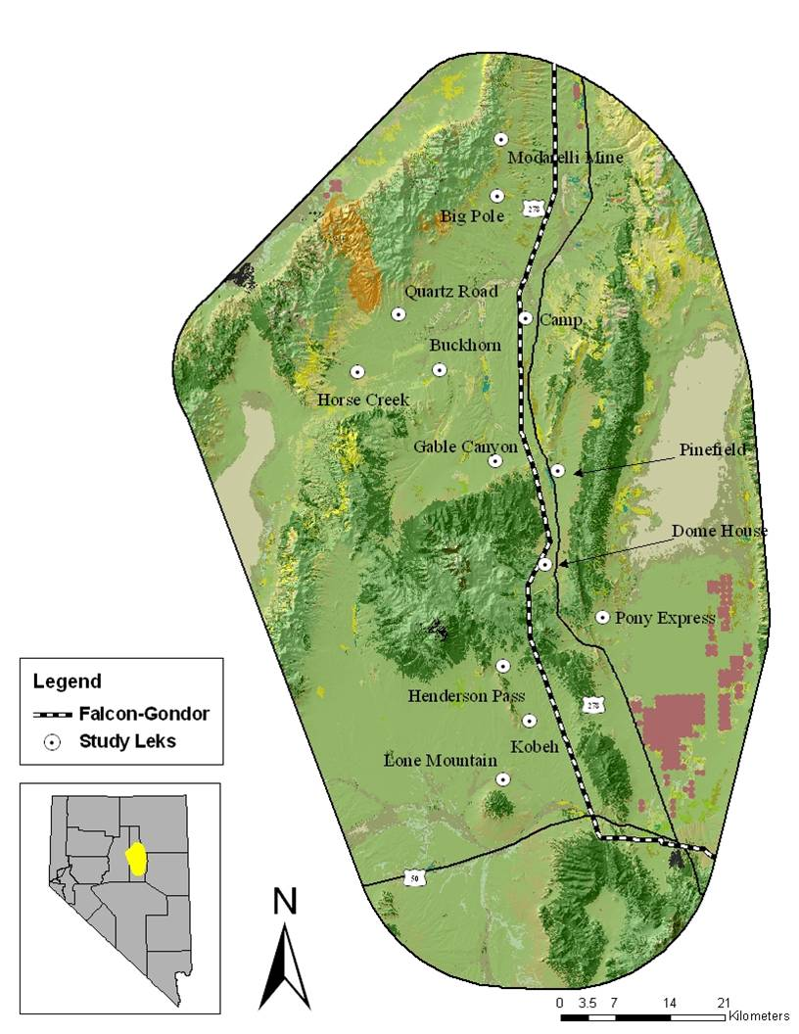
Figure 1. Lek locations in Study area.
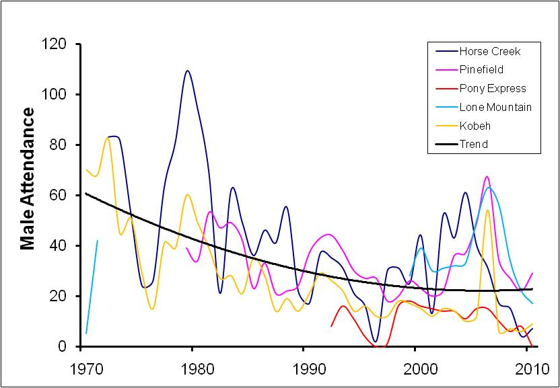
Figure 2. Long term trends in male attendance for 5 NDOW trend leks used in this study.

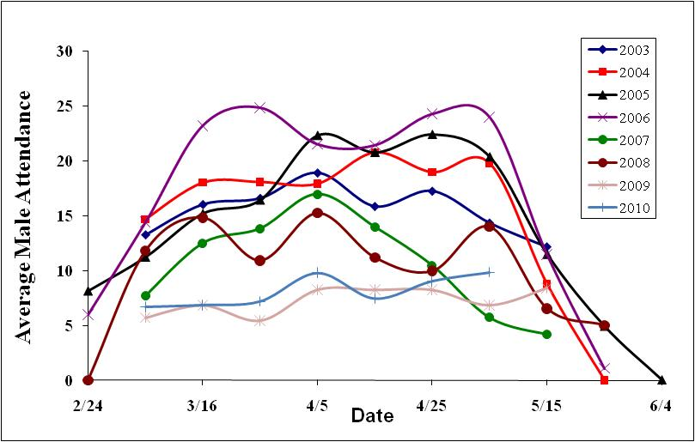
Figure 3. Summary of male lek attendance for all years of the study, using 10 day averages.

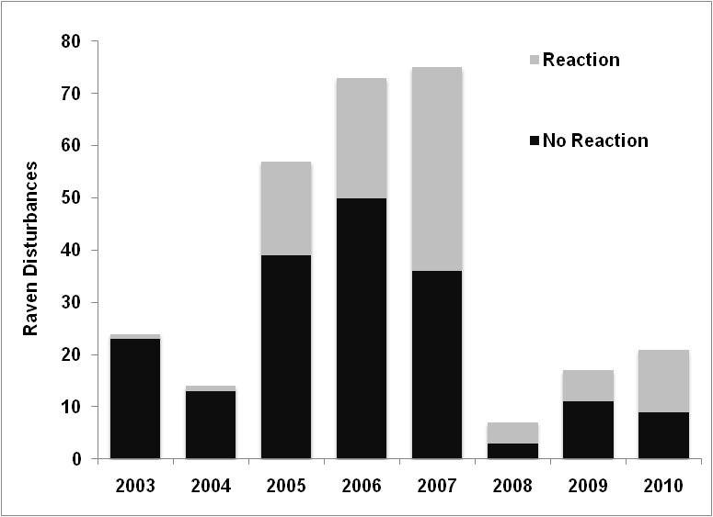
Figure 4. Sightings of Common Ravens at Greater Sage-Grouse leks in Eureka County, Nevada. Common Ravens were considered to have elicited a reaction from the sage grouse if any males ceased strutting activities or if any sage grouse (male or female) ducked down, hid, or flushed.

A

B

Figure 5. Comparison of estimated monthly survival (± SE) for all radio collared adult hens in the Cortez and Roberts populations (a), and comparison of estimated monthly survival for all radio collared adults hens trapped on the spring breeding grounds versus the fall brood rearing areas (b).
Figure 6. Annual survival estimates (± SE) for spring and fall caught hens that successfully fledged a brood compared with those who were unsuccessful.

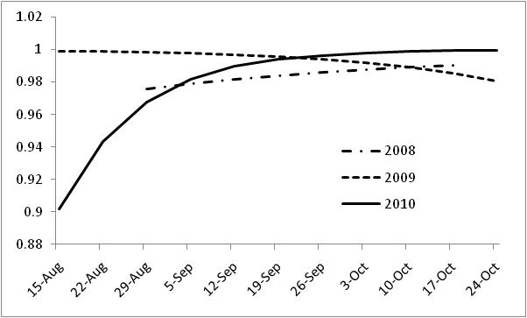
Figure 7. Patterns in weekly survival of sage-grouse during the months of August through October, 2008-2010.

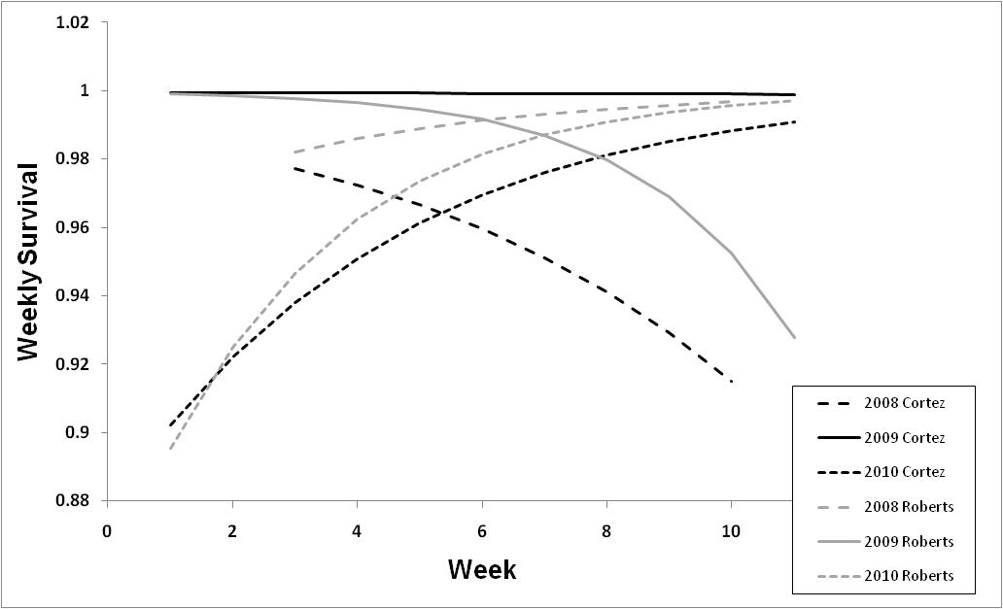
Figure 8. Interactions between year, population, and weekly trends in survival of female sage-grouse. Week 1 begins on 15 August.

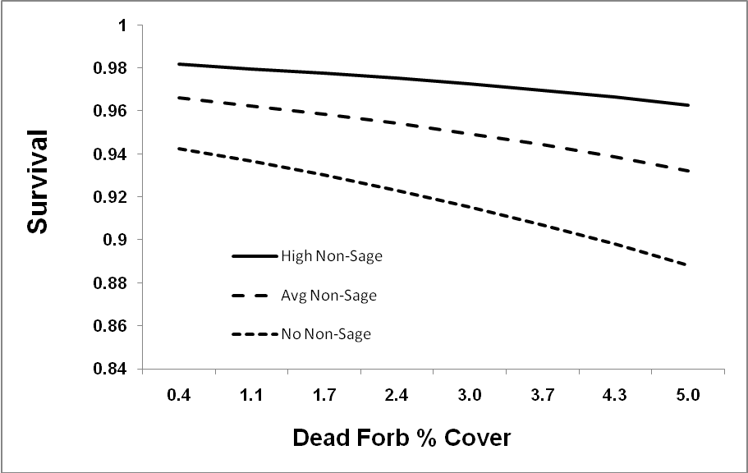
Figure 9. Relationship between % cover of dead forbs measured at flush sites, and monthly survival of female sage-grouse during the months of August – October, 2008-2010. A positive relationship between % cover of non-sagebrush shrubs and survival was also supported, as indicated by the alternative trend lines.

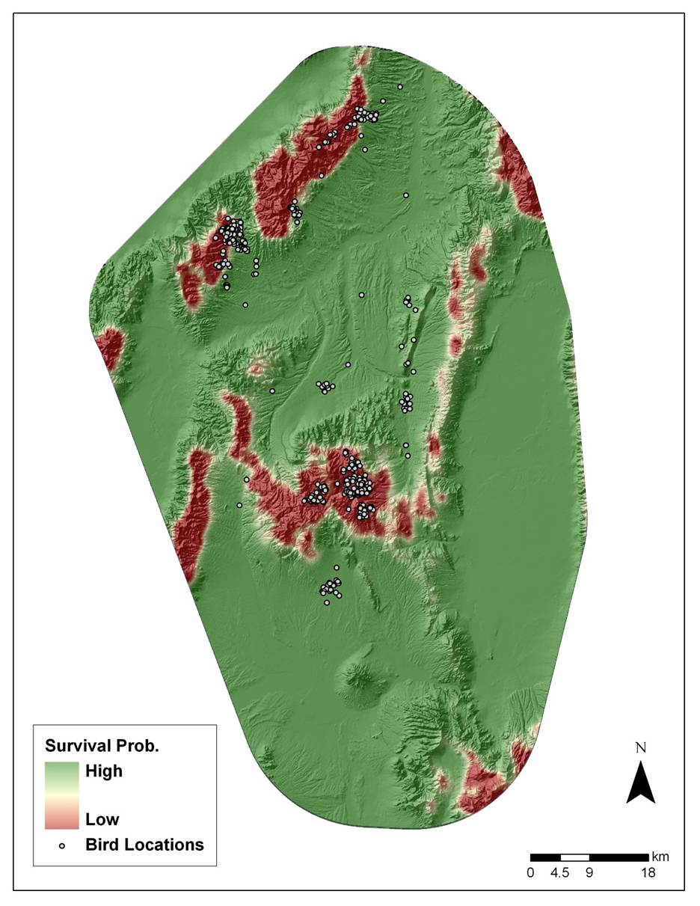
Figure 10. Graphic depiction of fall survival of female sage-grouse in relation to abundance of mountain sage-brush habitat. Female locations are shown for comparison.

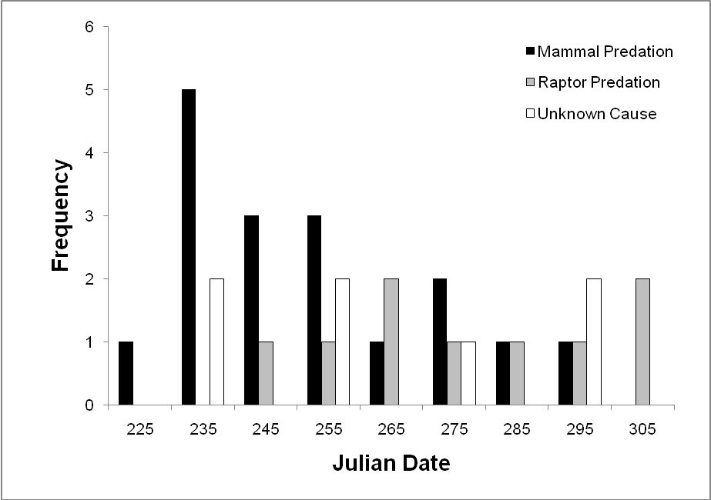
Figure 11. Temporal patterns in cause-specific mortalities of radio-collared sage-grouse from Aug-Oct, 2008 - 2010. Mortalities are binned into 10-day periods, and julian date 225 = August 14th.

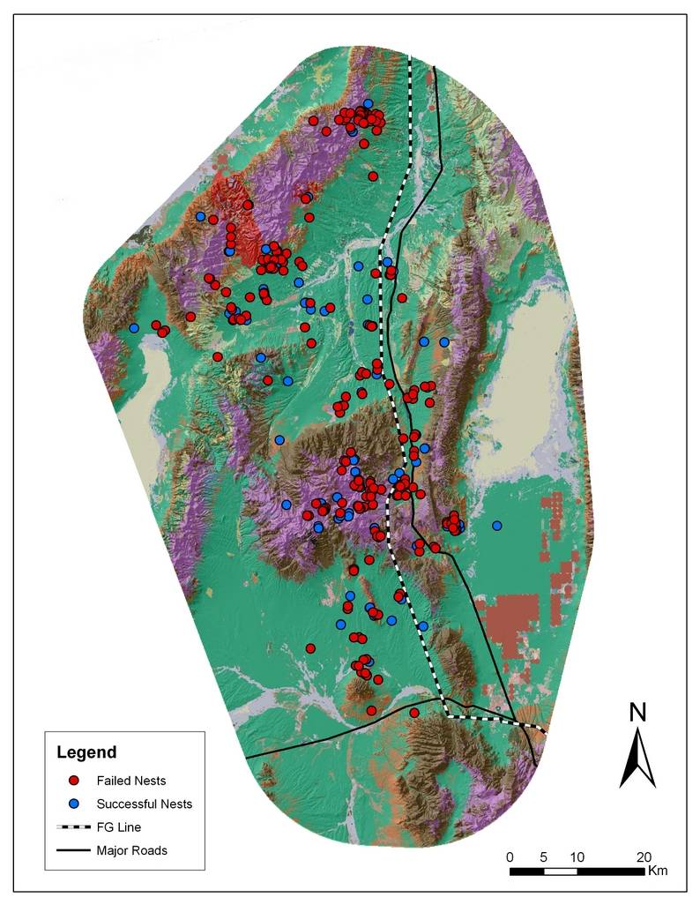
Figure 12. Nest locations in the study area from 2003-2010.

Figure 13. Relationship between estimated nest success and clutch size (a), and the relationship between estimated nest success and distance from road considering different amounts of wildfire impact (b)

Figure 14. Trends in weekly nest survival (± SE) of female sage-grouse given interactions between individuals originally trapped on leks in the spring (Spring) and individuals originally trapped in fall habitats (Fall). .

Figure 15. A comparison between frequency of nest initiation dates and the effect of nest initiation date on overall nest success.

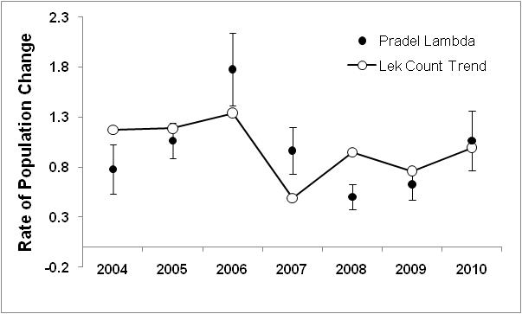

Figure 16. Comparison of rate of male population change (λ) based on lek counts and Capture-Recapture Pradel models. Capture-Recapture estimates are presented with standard errors.

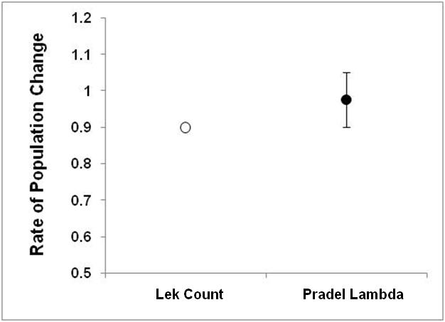
Figure 17. Comparison of long-term population trends derived from lek counts and a λ (.) model from a Pradel model analysis of male capture-recapture data.

Figure 18. Effect of relative body condition on annual survival of male sage-grouse.

Figure 19. Impact of wildfire surrounding lek sites on survival of male sage-grouse.

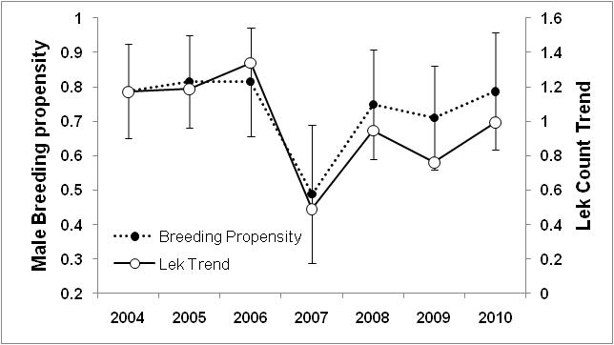
Figure 20. Estimates of annual breeding propensity (±SE) of male sage-grouse, estimated from Gamma’’ derived from a Robust Design model, compared to population trend estimates derived from lek counts.

